Capstone Lab 3

Capstone Lab 3.1
Question 5/7 – Please fill out the table. You will be repeating steps 3-6 to complete this.
Application | UDP or TCP | IPv4, IPv6, or Both?  (use 4, 6, or B) | Destination Port
DHCP | UDP | IPv4 | 67
DHHCv6 | UDP | IPv6 | 547
DNS | UDP | Both | 53
HTTP | TCP | Both | 80
SNMP | USP | IPv4 | 161
Telnet | TCP | Both | 23
TFTP | UDP | Both | 69

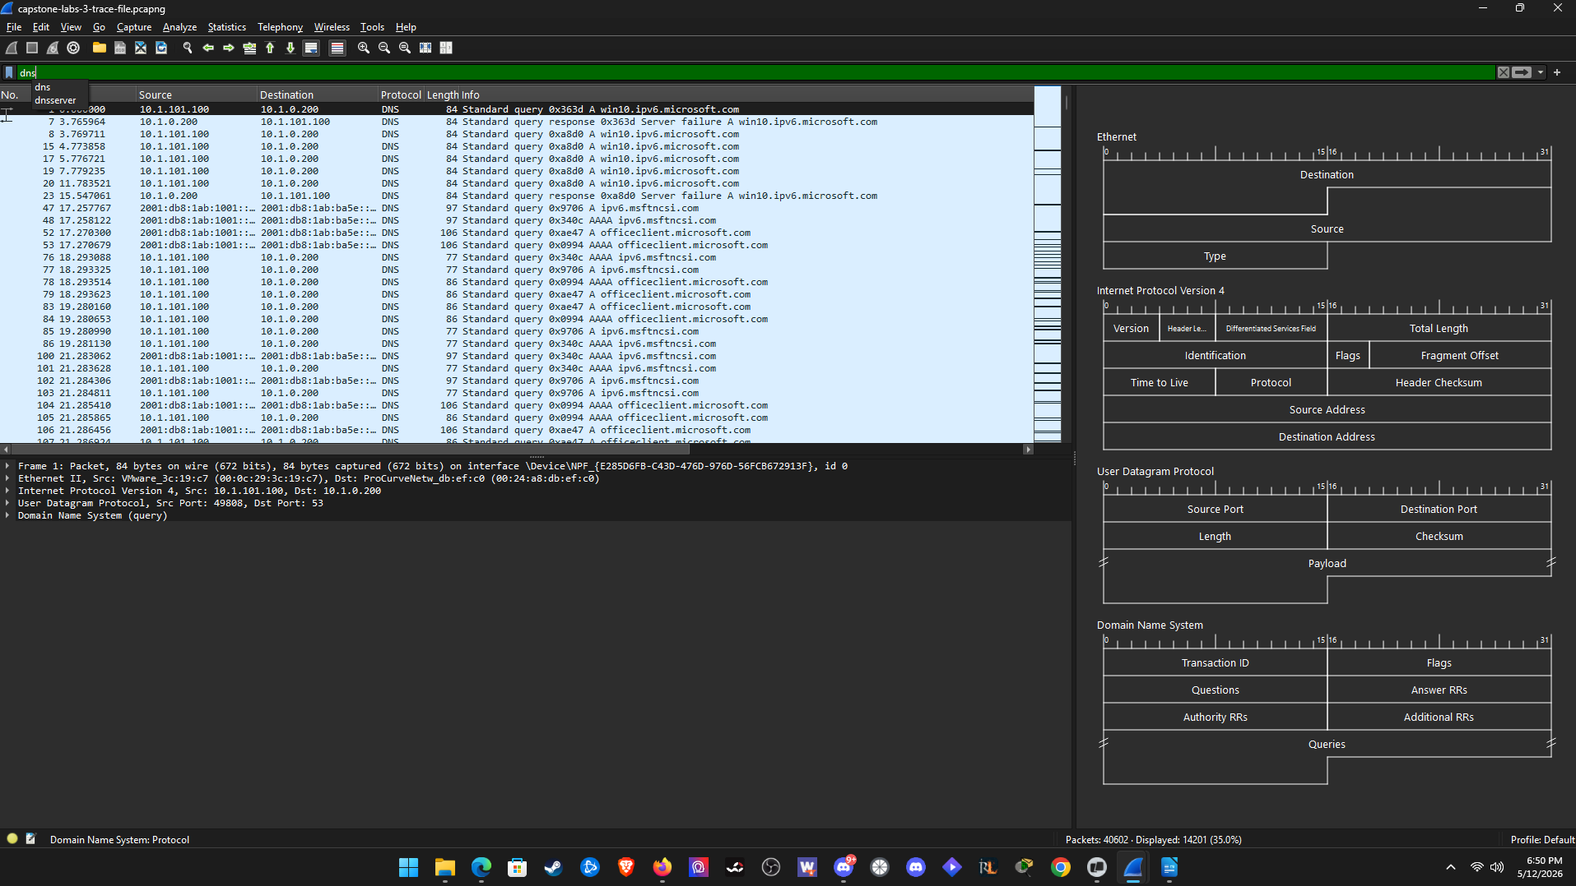
Question 8 – Please answer lab summary question.
In this part of the lab, I configured 7 display filters. Dhcp, dhcpv6, dns, http, snmp, telnet, tftp. I applied them to the capstone trace file and then observed a packet for each application listed to find the transport layer protocol used, the IP version used, and the destination port used.

Capstone Lab 3.2
Question 5 – Please answer the question.
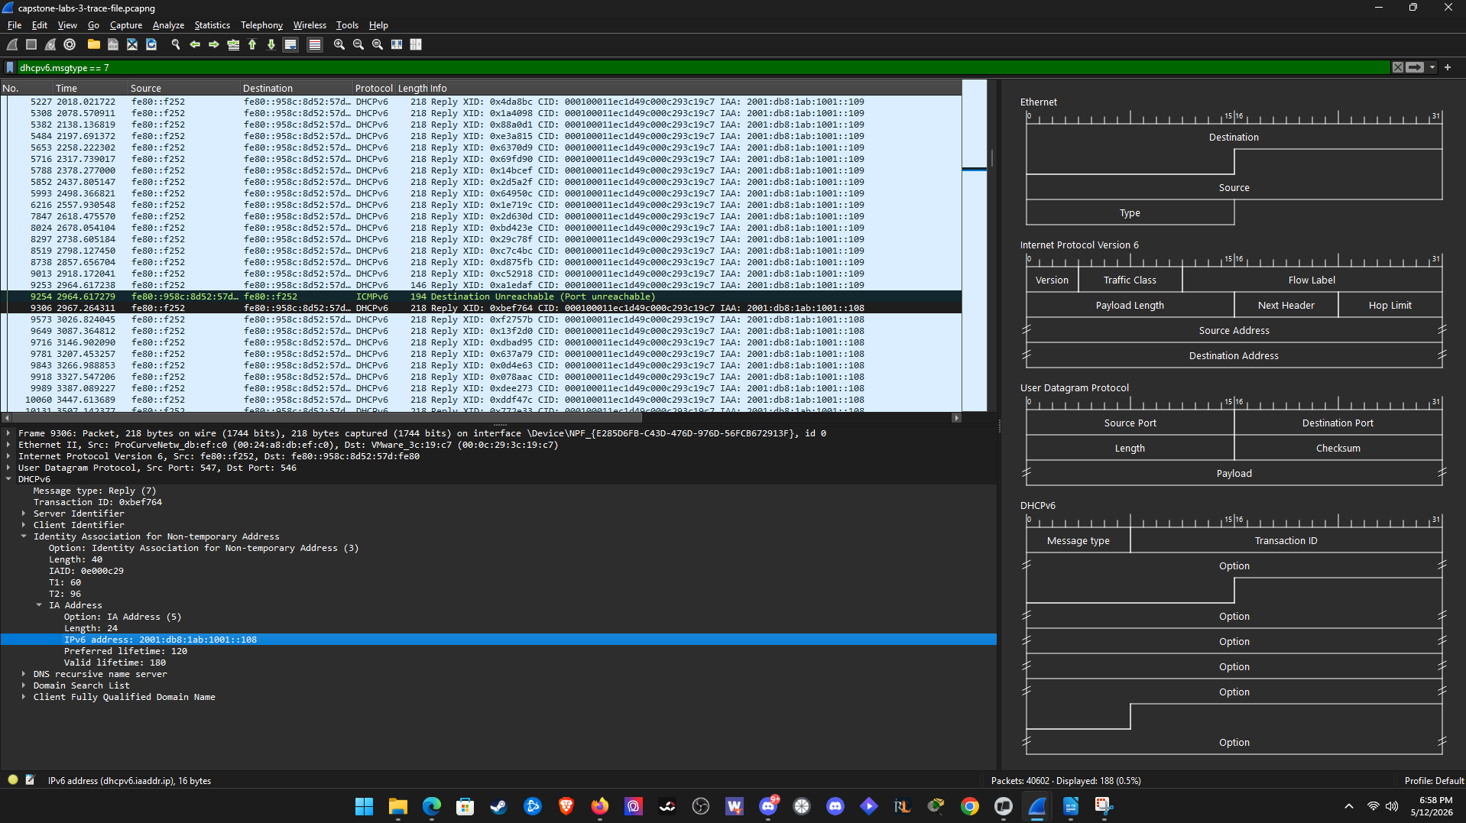
The first DHCPv6 replay supplies the Windows 10 host with its address is Frame 9306.
(Optional Bonus Question) Question 6 – Please answer the question.
The filter you can create is dhcpv6.iaaddr.ip == 2001:db8:1ab:1001::108
Question 7 – Please answer lab summary question.
In this part of the lab, I correlated the Ipconfig output information shown in the windows 10 host with the DHCPv6 exchange in the trace file. I used a dhcpv6 display filter and looked for reply messaged then found the IA address that corresponded to the windows 10 host to confirm the first packet where the server delivered its address to the client.

Capstone Lab 3.3
Question 1a – Please answer the question, including which flags, and what they do.
Flags
M. Managed config value is set to 1. ipv6 nd ra managed-config-flag
O. Other config value is set to 0. No other-config-flag command
L. On-link value is set to 0. No explicit on-link setting
A. Autonomous value set to 0. no-autoconfig on the prefix

Question 1b – Please answer the question about the O and L flags.
Flags
O. not set Other config is off unless ipv6 nd ra other-config-flag is added
L. set On-link is on by default for an advertised prefix unless no-onlink is added

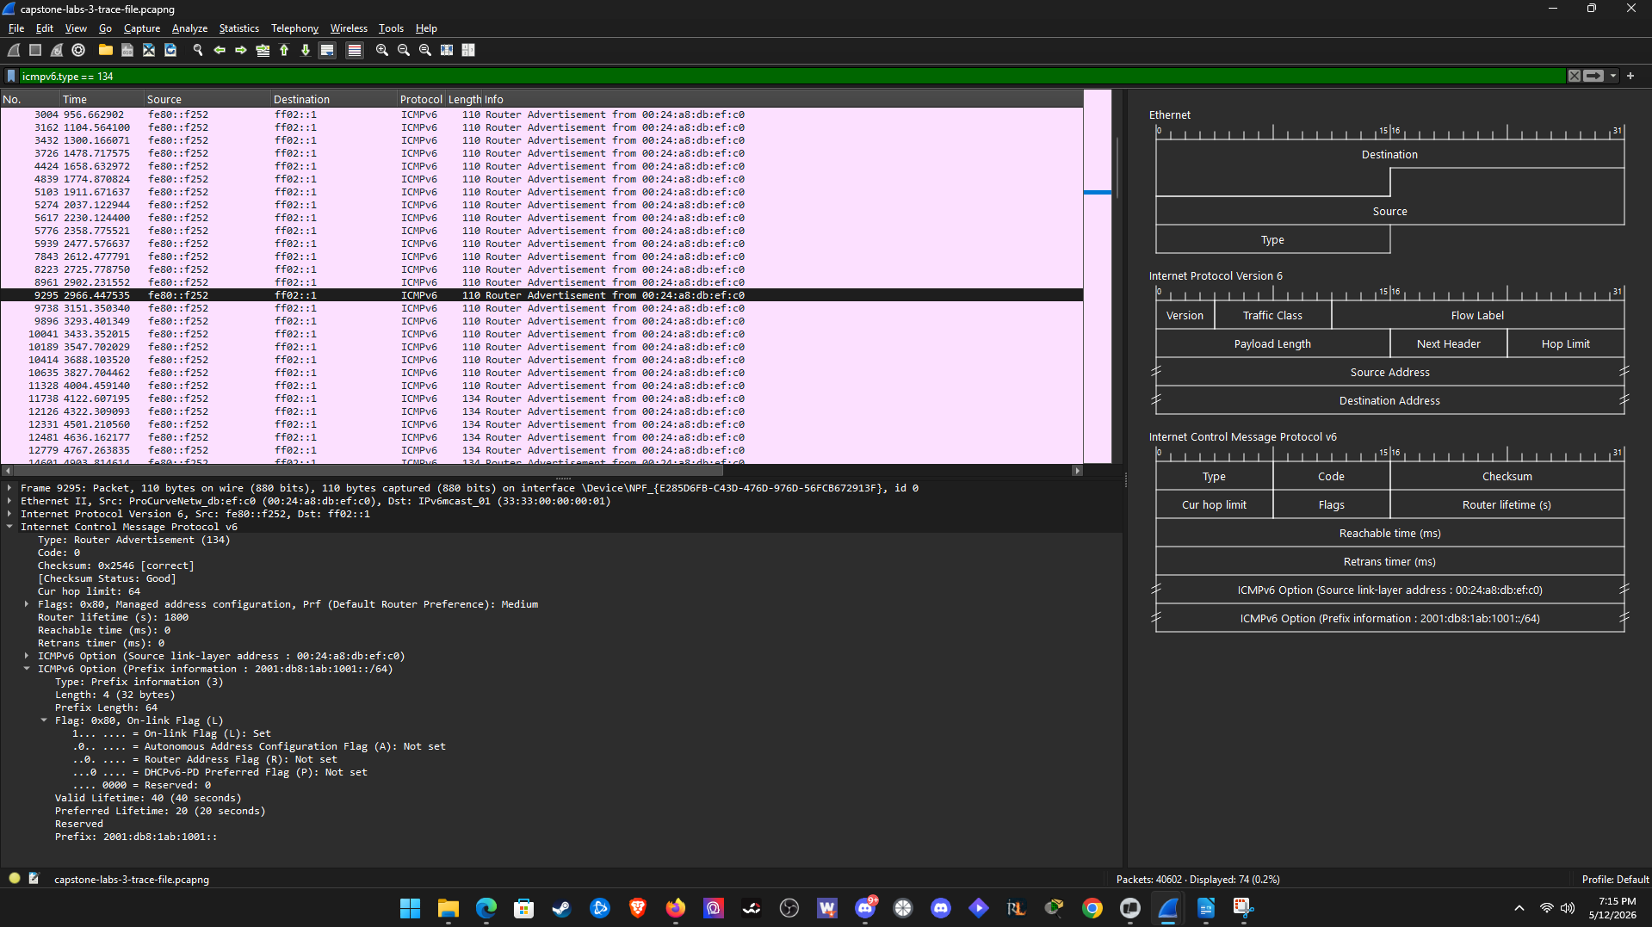
Question 7 - Please answer the question.
No there is no difference between the flag values with wireshark but O and L flags do show up with there vaules which I assume are the defaults.
(Optional Bonus Question) Question 8 - Please answer the question.
I think the layer 3 switch is providing DHCPv6 relay function for vlan 2 The server it is sending requests to is 2001:db8:1ab:ba5e::2000.
Question 9 – Please answer lab summary question.
In this part of the lab, I filtered the trace for ICMPv6 type 134 packets which are from the layer 3 switch. I expanded the flag fields and recorded the values and compared them to the vlan 2 configuration in the figure. The trace values matched both the configured flags and default flags which confirmed that the switch is correctly configured.

Capstone Lab 3.4
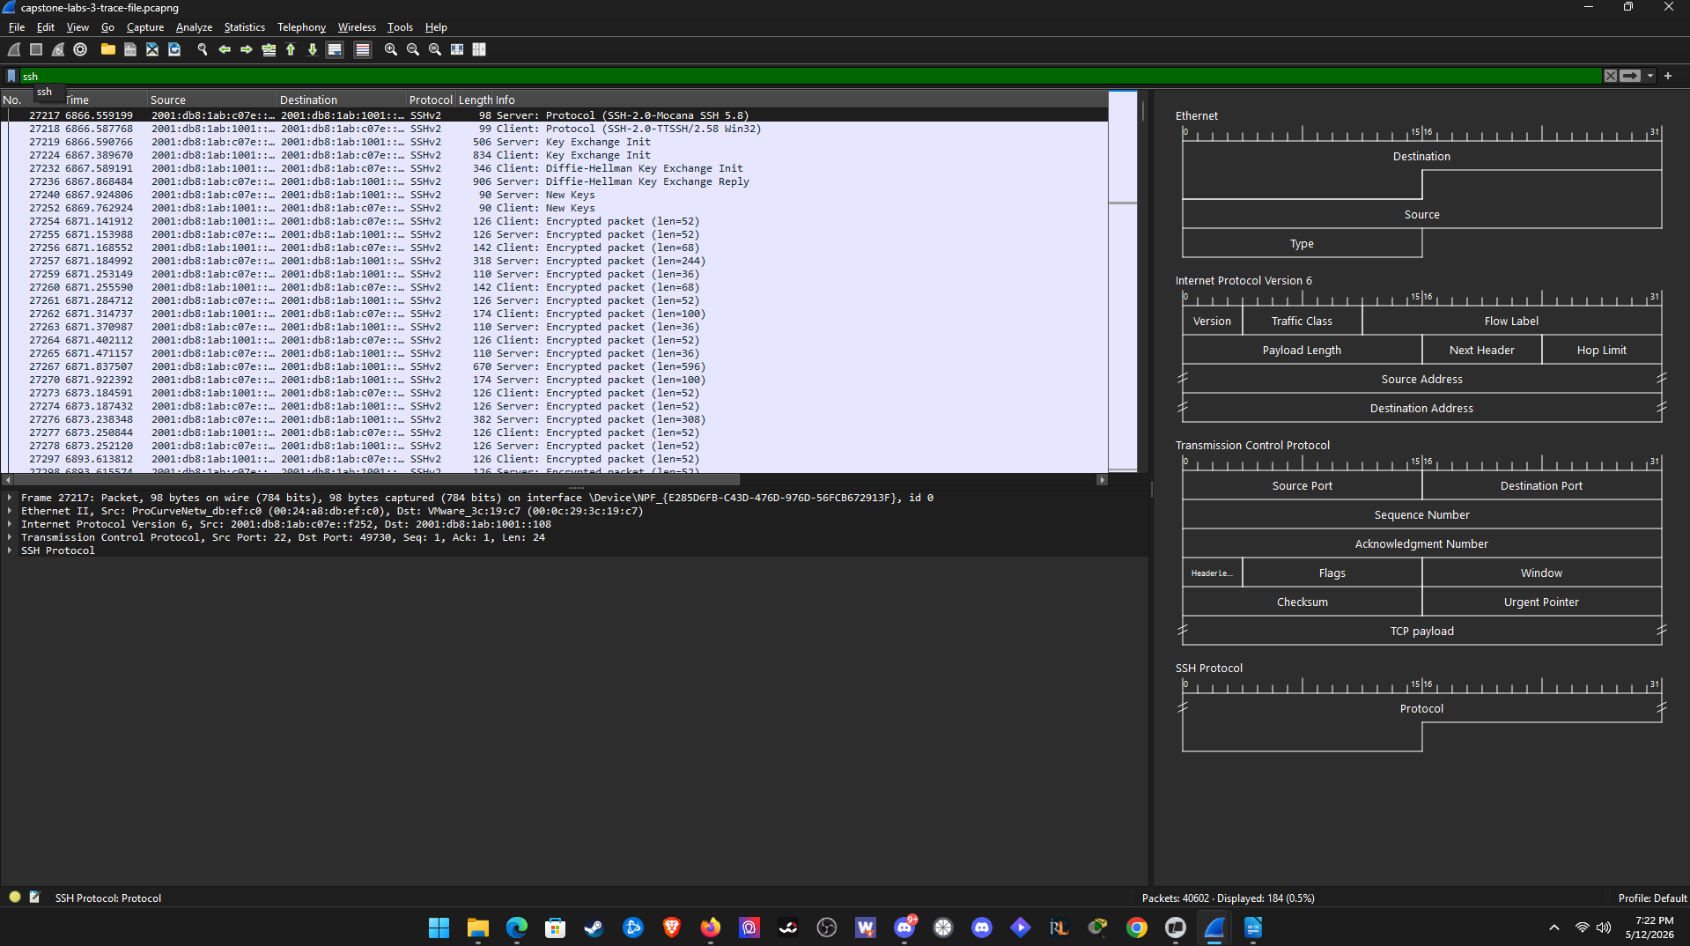
Question 4 – Please answer the question.
Frame 27218
Question 5 - Please answer the question.
No, only the banner and algorithm names are readable.
Question 6 - Please answer the question.
Frame 27364
Question 7 - Please answer the question.
No, on the banner and algorithm names are readable.
Question 11 - Please answer the question.
Frame 27902
Question 12 - Please answer the question.
No. TLS encrypts all the data.
Question 13 - Please answer the question.
Frame 29910
Question 14 - Please answer the question.
No. It is TLS encrypted
Question 15 – Please answer lab summary question.
In this part of the lab. I configured display filters for ssh and https and inspected the Bytes pane to see if you can see any of the data sent in these packets in clear text. I found out that any of the data is encrypted over these two protocols and you can only see the banners or handshake information.

Capstone Lab 4

Capstone Lab 4.1
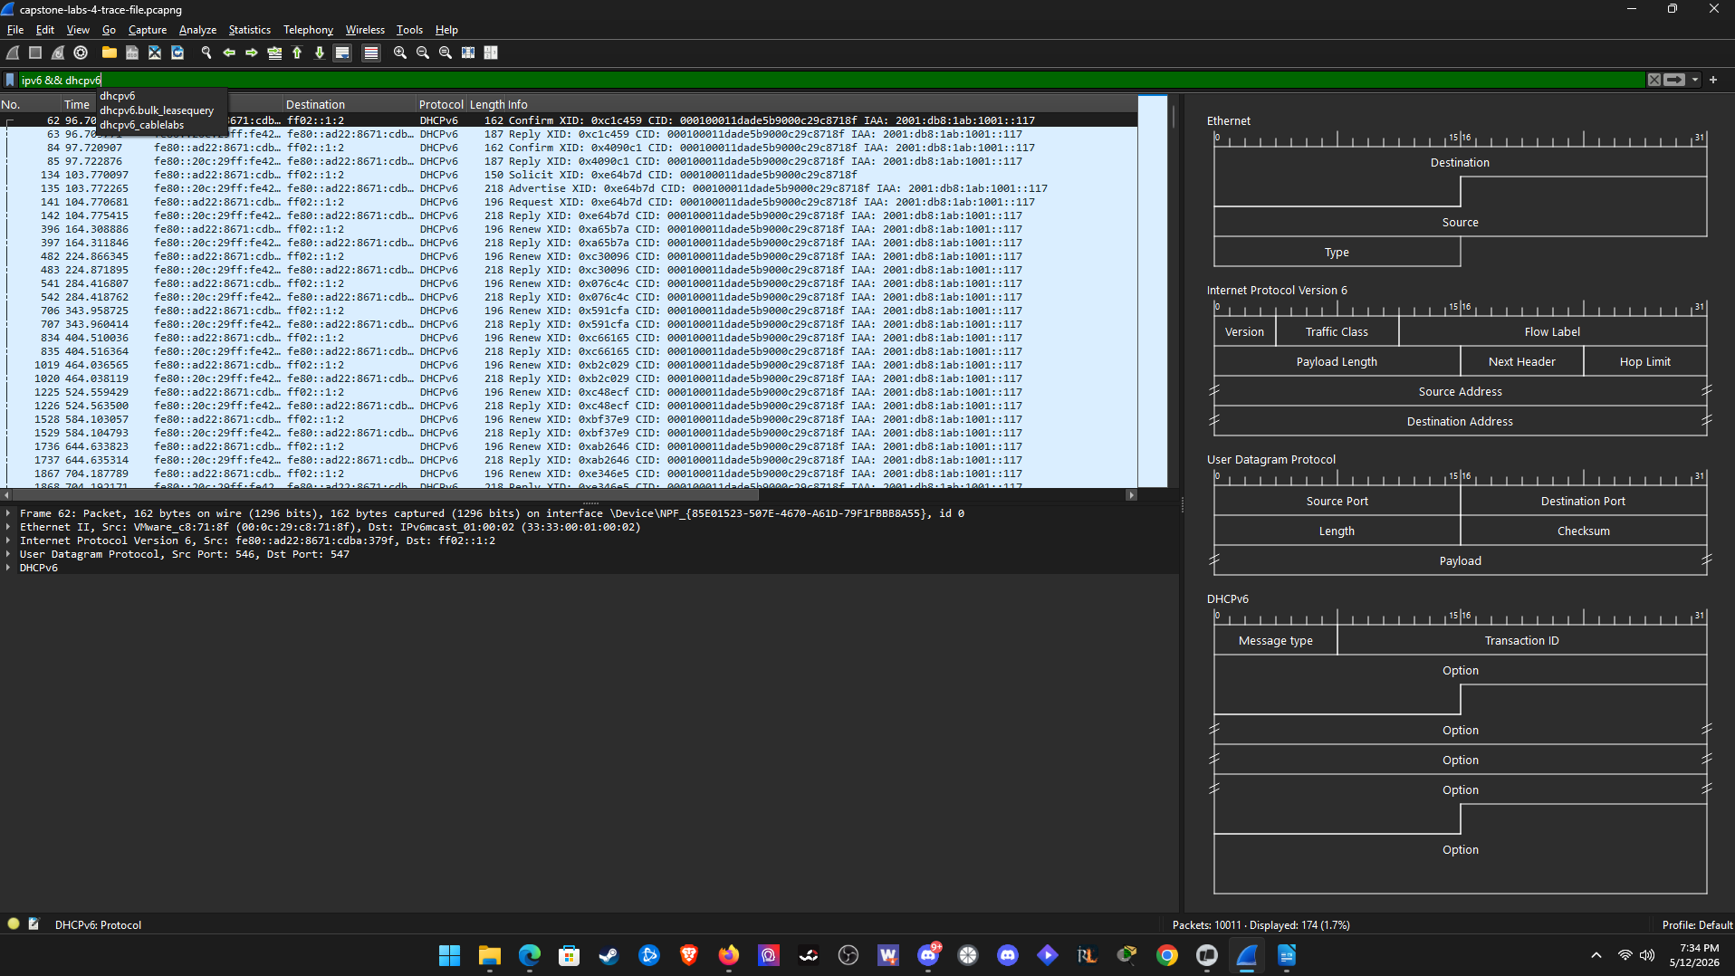
Question 5 – Please answer the question.
2001:db8:1ab:1001::117
Question 7 – Please answer the question.
Target address – 2001:db8:1ab:1001::117
Source MAC – 00:0c:29:c8:71:8f
Question 9 – Please answer question.
Target address – 2001:db8:1ab:1001::117
Source MAC – 00:0c:29:79:f7:09
Question 11 - Please answer the question.
ICMPv6 Option – 00:0c:29:c8:71:8f
Yes it is the same as step 7 and no it is not the same as step 9
Question 12 - Please answer the question.
2001:db8:1ab:1001::117 this is also a duplicate as the last.
Question 14 - Please answer the question.
First ping did not use -6 flag address used was 10.1.0.200 and 2 successful replies.
Forced ping uses -6 flag and there was no usable IPv6 source. The result was Ping request could not find host http://www.ipv6sandbox.com. Please check the name and try again.

Question 15 – Please answer lab summary question.
In this part of the lab, I filtered the trace fore IPv6 traffic and traced the Ipv6 address conflict between the two windows hosts. I found out that the Windows 7 host hasd been manually configured with an address already in use so the ipconfig output for the Windows 7 host showed the IPv6 address a duplicate. With dual stack setup it fell back to IPv4 which worked but when you tried to force IPv6 pings it failed outright.

Capstone Lab 4.2
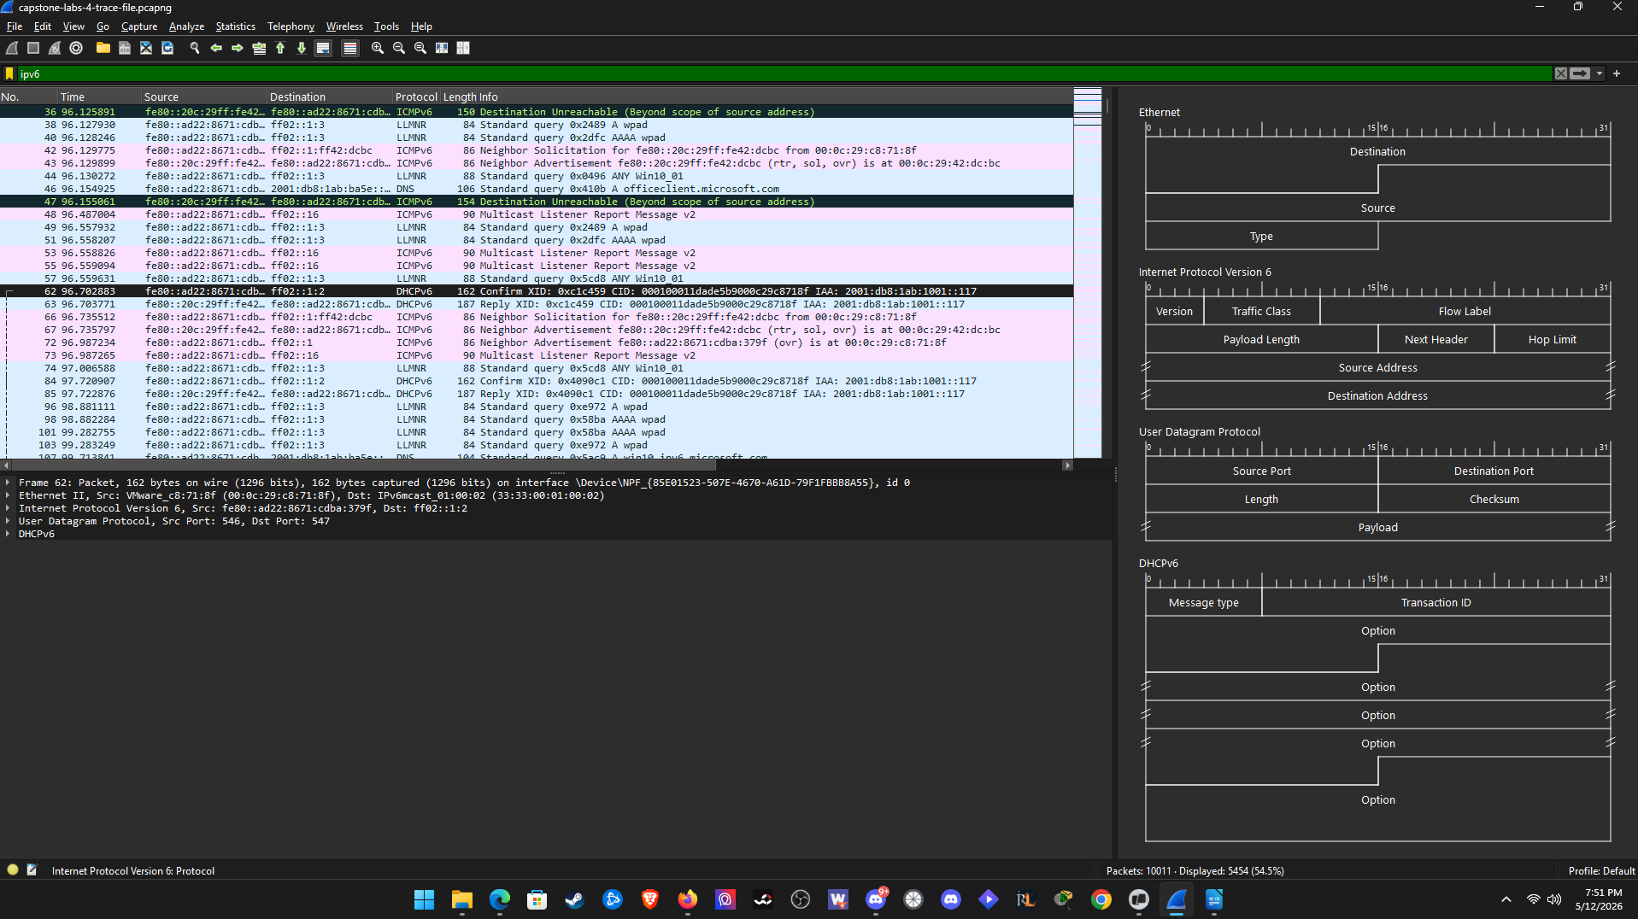
Question 1 – Please answer the question.
2001:db8:1ab:1001::117 (Preferred)
Question 5 - Please answer the question.
Frame 6223
Question 6 - Please answer the question.
Frame 6880
Question 8 - Please answer the question.
Flags
M = 1
O = 0
L = 1
A = 1
Question 9 - Please answer the question.
2001:db8:1ab:1001:ad22:8671:cdba:379f
2001:db8:1ab:1001:e9fa:726f:dfbd:4d24
Flag A caused the new addresses.
Question 10 - Please answer the question.
Frame 6913
Source IPv6 – 2001:db8:1ab:1001:e9fa:726f:dfbd:4d24
Question 11 - Please answer the question.
It is labeled as a Temporary IPv6 address.
Windows most likely prefers this address over the public SLAAC address and the DHCPv6 assigned address.
Question 12 - Please answer the question.
Frame 7512
Question 14 - Please answer the question.
Flags
M = 1
O = 0
L = 1
A = 0
Question 16 - Please answer the question.
Both SLAAC addresses dropped from preferred to deprecated.
Question 17 - Please answer the question.
Source IPv6 = 2001:db8:1ab:1001::117
Same as step 1 but its is not the same as step 10.
Question 18 – Please answer lab summary question.
In this part of the lab, I filtered the trace file for IPv6 traffic and followed the Windows 10 hosts address changes. The host generated both public and temporary SLAAC addresses which conflicted with windows and the specific flags that were set. Since the A flag was set too 0 is frame 7512 the SLAAC addresses were deprecating. This shows how the A flag in a single router advertisement can change which source a windows host uses.

Capstone Lab 4.3
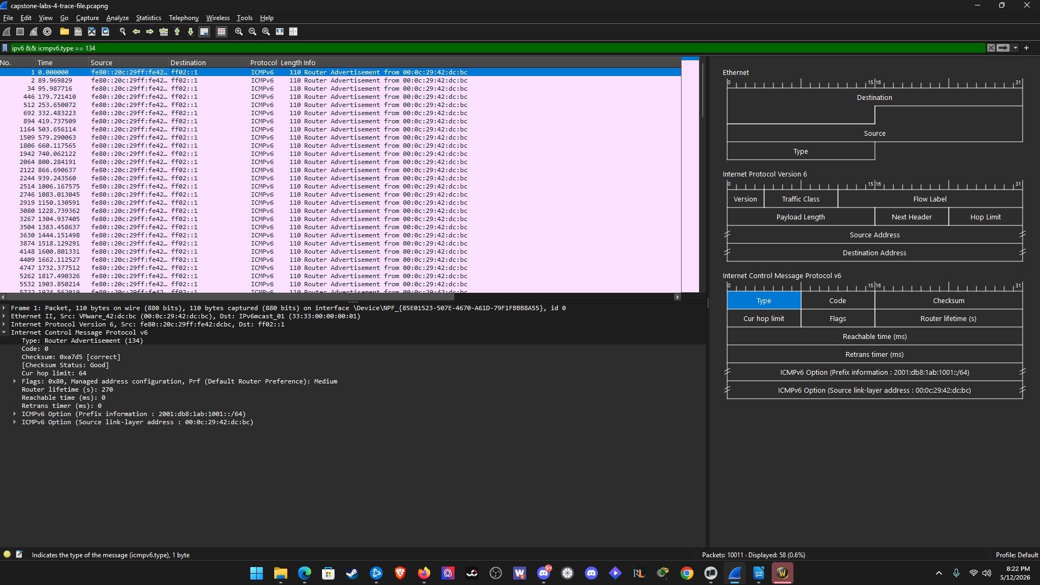
Question 1 – Please answer the question.
IPv6 GUA = 2001:db8:1ab:1001::117 (Preferred)
Default Gateway: fe80::20c:29ff:fe42:dcbc%16 (IPv6) and 10.1.101.1 (IPv4)
Question 7 - Please answer the question.
Flags
M = 1
O = 0
L = 1
A = 0
Router lifetime setting = 270 seconds
Question 8 - Please answer the question.
First ping in the group of four = Frame 9660
Question 9 - Please answer the question.
The IPv6 default gateway is now gone only the IPv4 default gateway is listed.
Question 10 - Please answer the question.
The Windows 10 host no longer has an IPv6 default gateway so the host cannot reach the off link destination 2001:db8:1ab:ba5e::2000 without one.
Question 11 - Please answer the question.
Frames 9725 and 9887
Question 12 - Please answer the question.
Router lifetime setting = 0 seconds
Question 13 - Please answer the question.
Router lifetime setting = 270 seconds
Question 14 - Please answer the question.
The difference between the two is 270 seconds.
Question 15 - Please answer the question.
First ping in the group of four is Frame 9991.
(Optional Bonus Question) Question 16 - Please answer the question.
When the host obtained its IPv6 address ::117 from the DHCPv6 lease it got a valid gateway. In the RA in frame 9725 it had a router lifetime of 0 which caused the windows client to immediately drop the IPv6 default gateway address. So the mechanism is router lifetime setting.

Question 17 – Please answer lab summary question.
In this part of the lab, I filtered the trace file for IPv6 traffic and the correlated Router Advertisements with the Windows hosts ability to reach off link IPv6 destinations. It originally had a valid RA which gave it an IPv6 default gateway. I then found out the next RA had a router lifetime setting of 0 which caused the windows host to drop its IPv6 default gateway. It was successfully restored later on in an RA that has a router lifetime setting of 270. Pings confirmed that this worked. This lab showed that IPv6 address state and IPv6 default gateway state are independent and a single RA can break IPv6 connectivity.

